**C-DAC Mumbai**

**Lab Assignment: 3**

* **Name:***Akash Bhadane*

**Problem 1: Sum of Two Numbers (Using a Method)/ (Notepad++)**

**Problem Statement:**

Write a Java program that includes a method to calculate the sum of two numbers.

1. Create a method sumOfTwoNumbers() that takes two integers as parameters, calculates their sum, and returns the result.
2. In the main method, use the Scanner class to prompt the user to enter two integers.
3. Pass the user inputs to the sumOfTwoNumbers() method and print the sum.

**Sample Input:**

Enter first number: 15 Enter second number: 25

**Expected Output:**

The sum of 15 and 25 is 40.

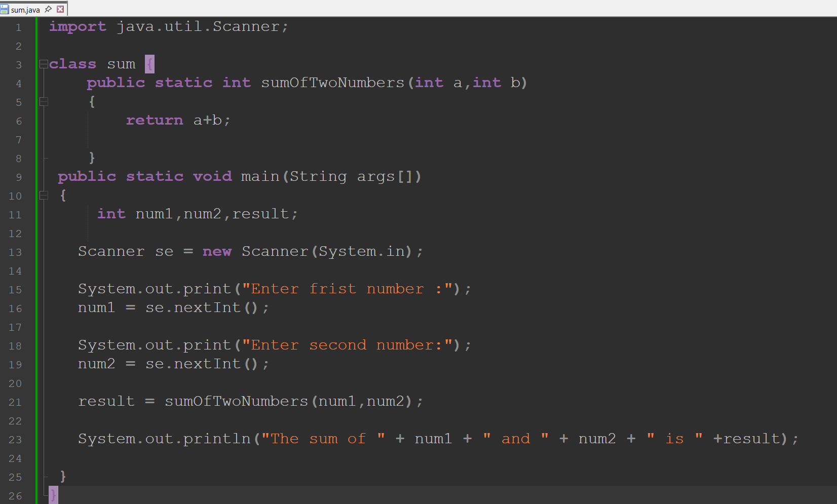

**Output:**

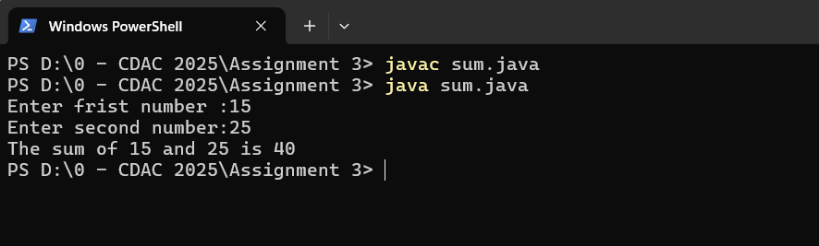

**Problem 2: Simple Age Checker (Using a Method)**

**Problem Statement:**

Write a Java program that includes a method to check the age category.

1. Create a method checkAgeCategory() that takes an integer (age) as a parameter and prints whether the user is a minor, adult, or senior citizen.
2. In the main method, use the Scanner class to prompt the user to enter their age.
3. Pass the user's age to the checkAgeCategory() method.

**Sample Input:**

Enter your age: 30

**Expected Output:**

You are an adult.

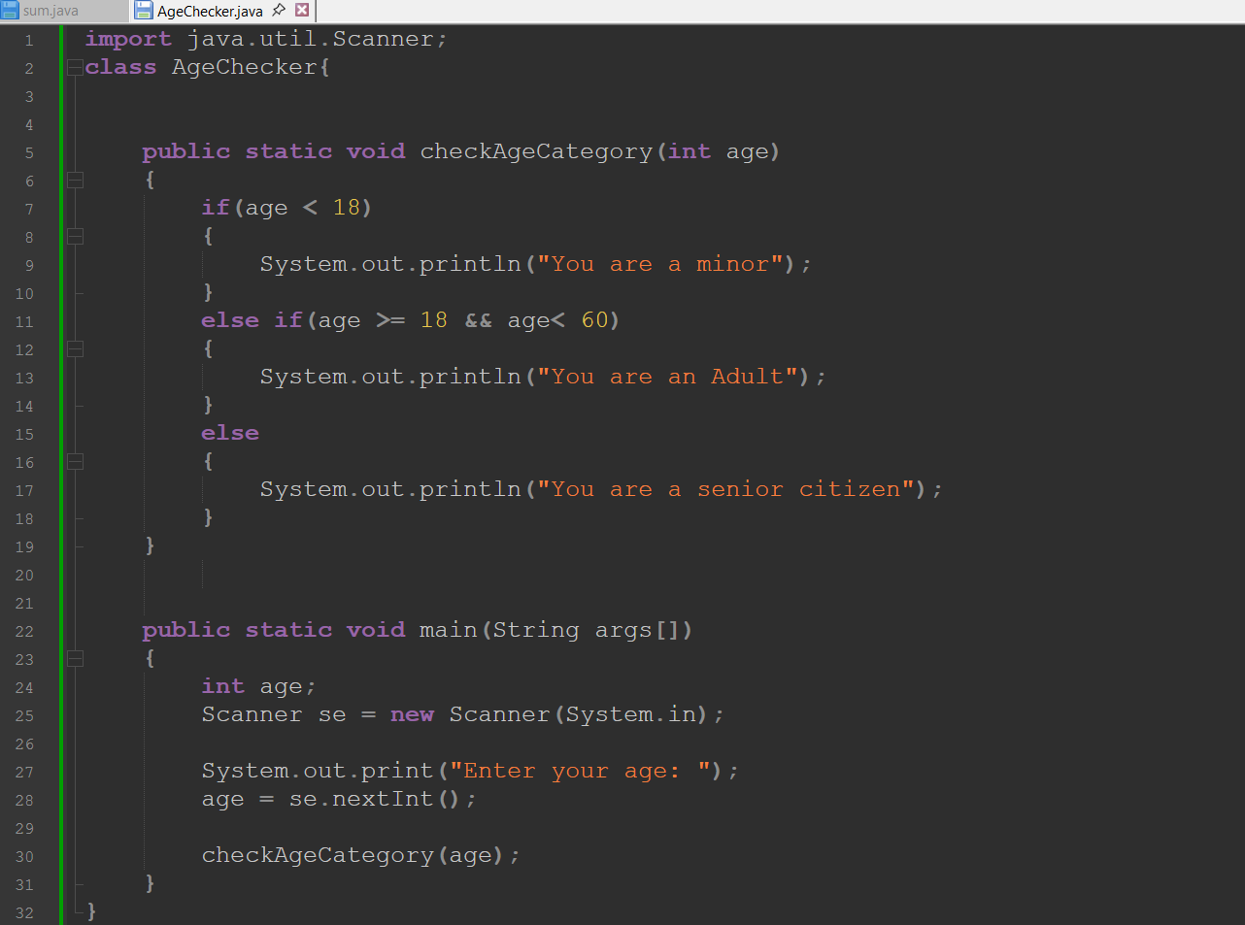

**OutPut:**

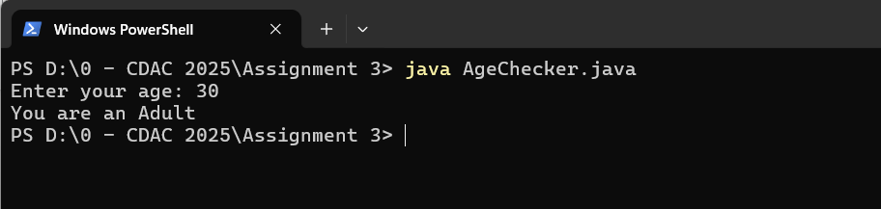

**Problem 3: Print Even Numbers (Using while Loop)**

**Problem Statement:**

Write a Java program that prints all even numbers between 1 and 50 using a while loop.

1. Create a method printEvenNumbers() that prints all even numbers from 1 to 50.
2. Use a while loop to iterate from 1 to 50 and print the even numbers.

**Sample Output:**

2 4 6 8 10 12 14 16 18 20 22 24 26 28 30 32 34 36 38 40 42 44 46 48 50

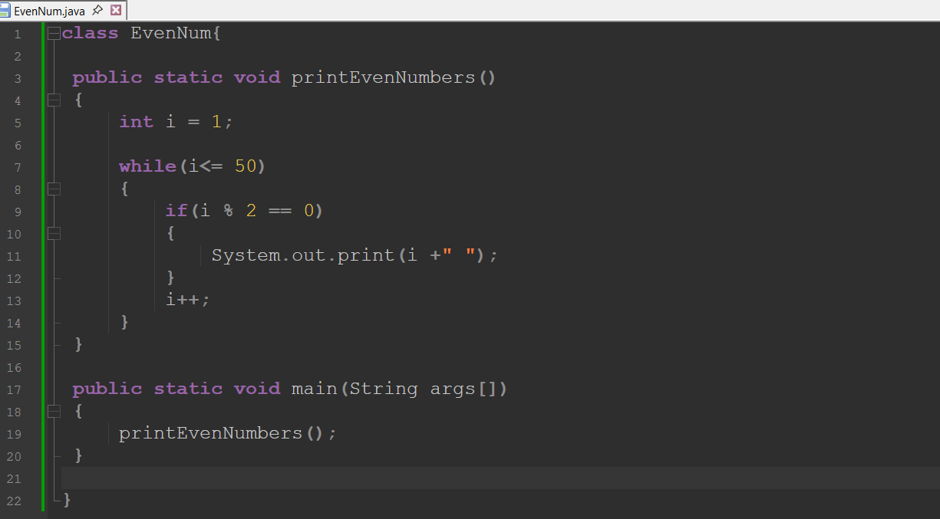

**Output:**

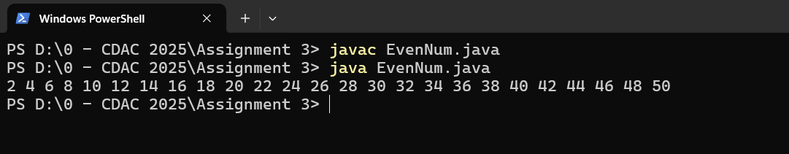

**Problem 4: User Input for Positive Numbers (Using do-while Loop)**

**Problem Statement:**

Write a Java program that repeatedly asks the user to enter a positive number.

1. Create a method askForPositiveNumber() that uses a do-while loop to ask the user for a number until they enter a positive number.
2. Use the Scanner class to take the user’s input.
3. Once a positive number is entered, the program should display the number.

**Sample Input:**

Enter a positive number: -5 Enter a positive number: 0 Enter a positive number: 8

**Expected Output:**

You entered a positive number: 8

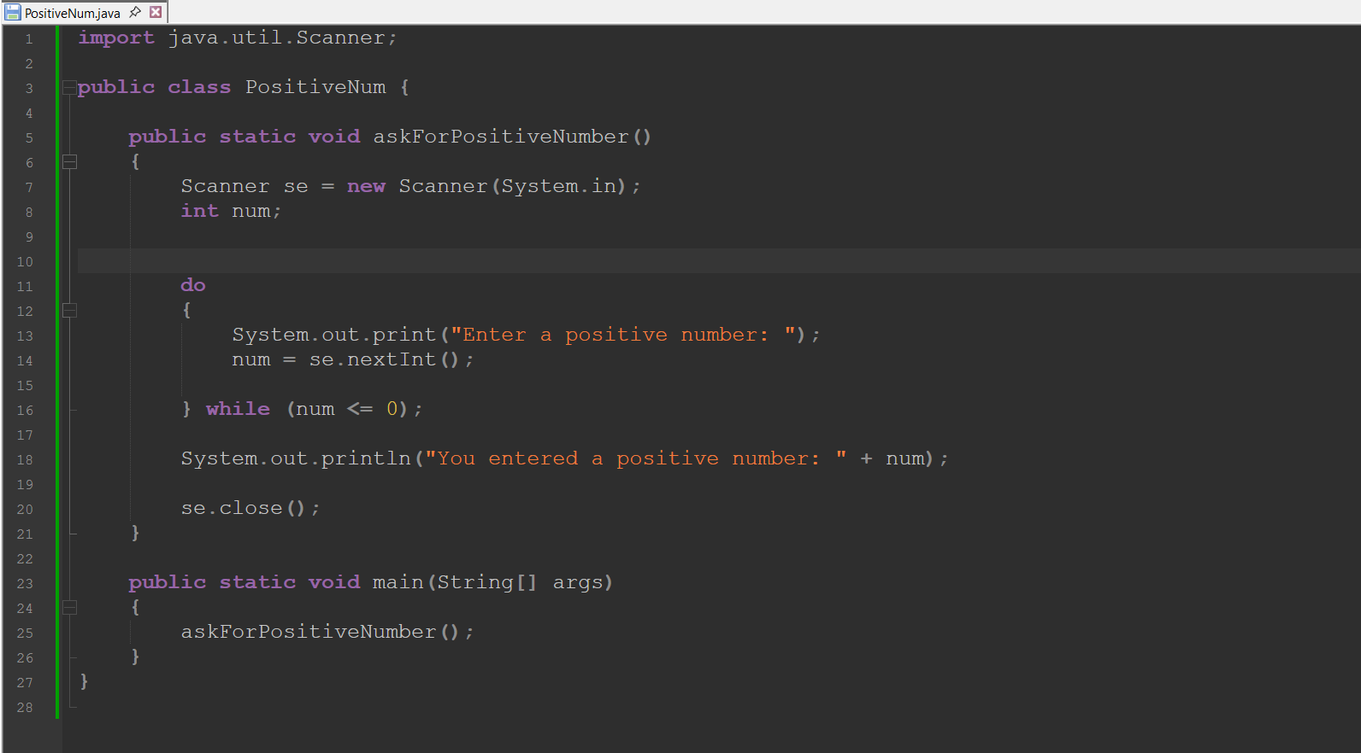

**Output:**

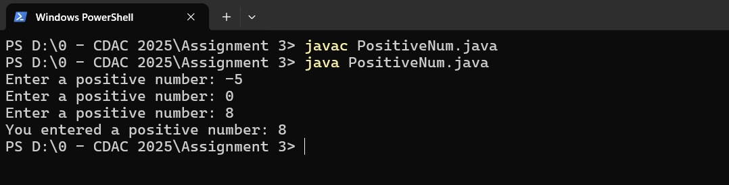

**Problem 5: Print Multiplication Table (Using for Loop)**

**Problem Statement:**

Write a Java program that prints the multiplication table for a given number (e.g., number 5) using a for loop. The program should:

1. Create a method printMultiplicationTable() that takes a number as a parameter and prints its multiplication table from 1 to 10.
2. Use a for loop to iterate through numbers 1 to 10 and print the multiplication results.

**Sample Input:** Enter a number: 5

**Expected Output:** 5 x 1 = 5

5 x 2 = 10

5 x 3 = 15

5 x 4 = 20

5 x 5 = 25

5 x 6 = 30

5 x 7 = 35

5 x 8 = 40

5 x 9 = 45

5 x 10 = 50

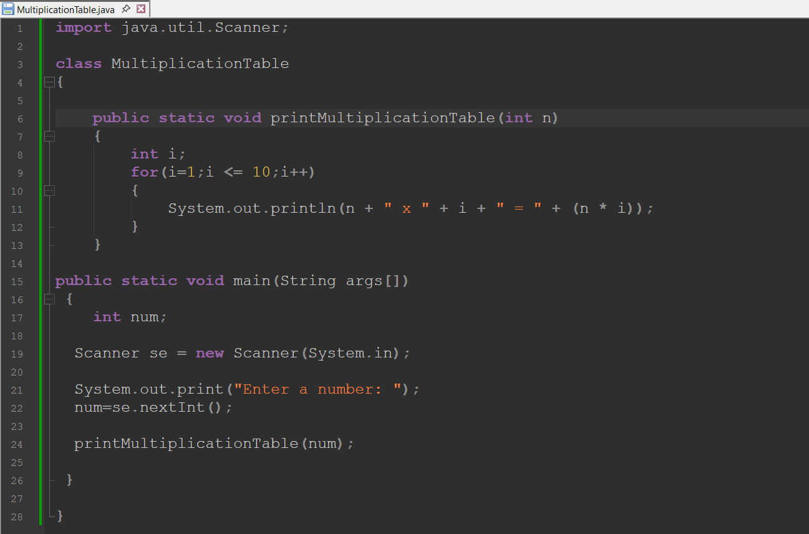

**Output:**

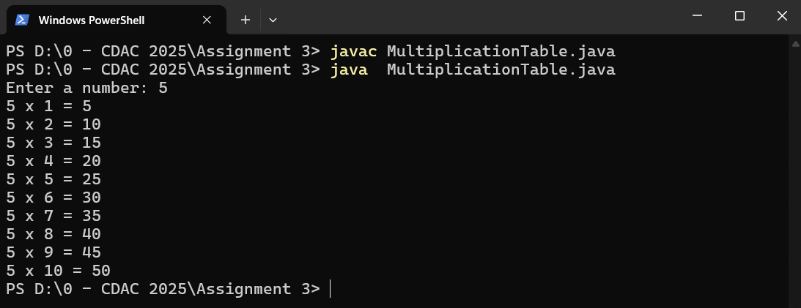

**Problem 6: Calculate the Sum of Numbers from 1 to N (Using for Loop)**

**Problem Statement:**

Write a Java program that calculates the sum of all integers from 1 to N (where N is a positive integer) using a for loop. The program should:

1. Create a method calculateSum() that takes a number N and calculates the sum of all integers from 1 to N.
2. Use a for loop to iterate through all integers from 1 to N and add them up.

**Sample Input:**

Enter a number: 5

**Expected Output:**

The sum of numbers from 1 to 5 is: 15

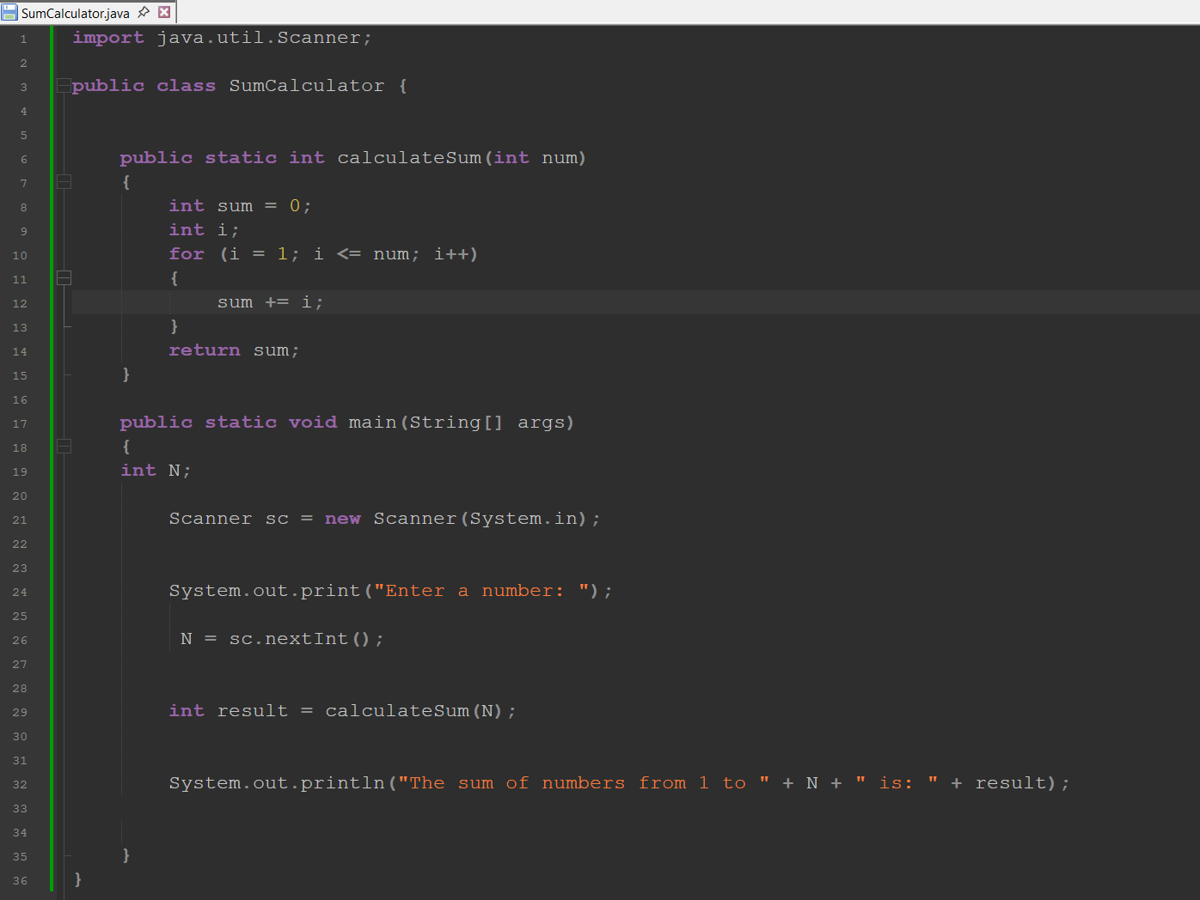

**Output:**

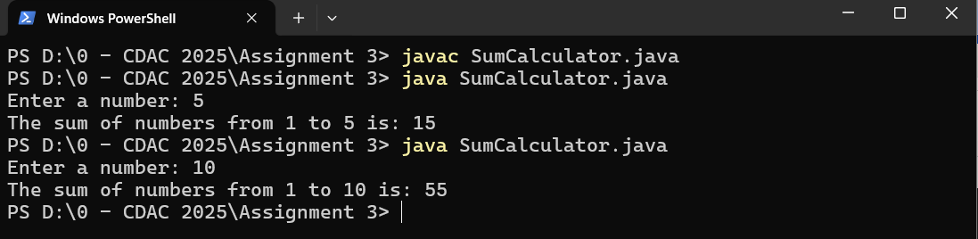

**Bonus Problem: Menu-Driven Java Program (Switch-Case)**

**Problem Statement:**

You are required to write a **menu-driven Java program** that implements **four separate problems**. The program should allow the user to select which problem to run, execute the corresponding logic, and then return to the menu until the user chooses to exit.

**The four problems are as follows (Already done in assignment 2, just put it in switch case):**

Problem 1: Grade Evaluation System Problem,2: Leap Year Check Problem ,3: Day of the week

Problem 4: Identify Default Values of Variables Case 5: Exit

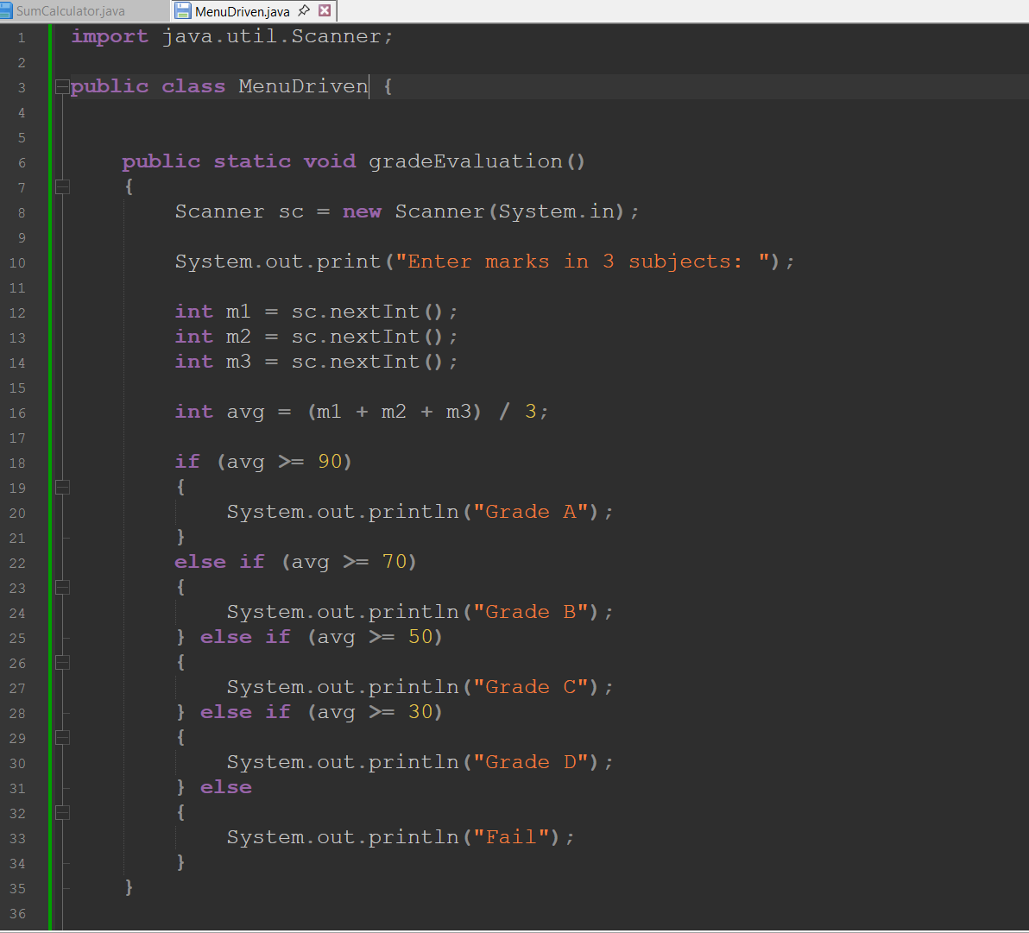

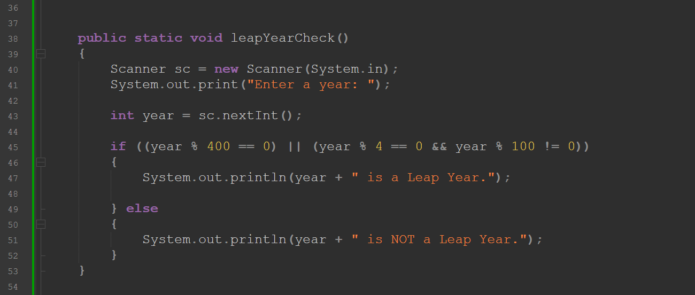

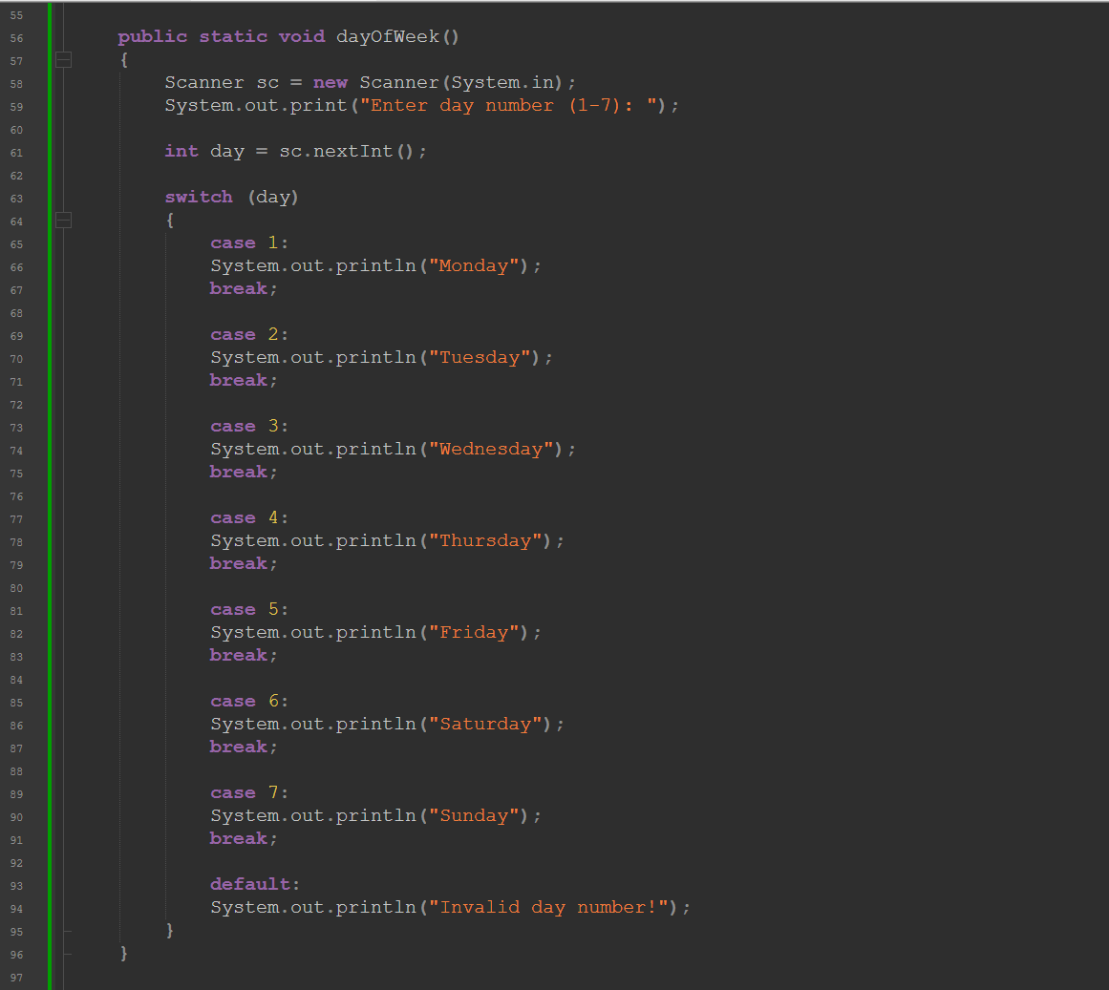

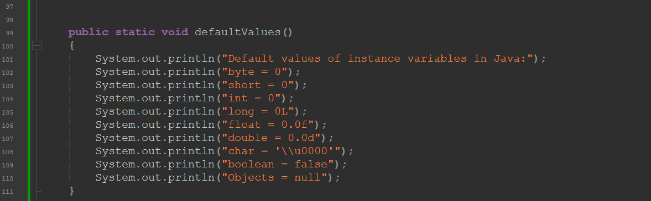

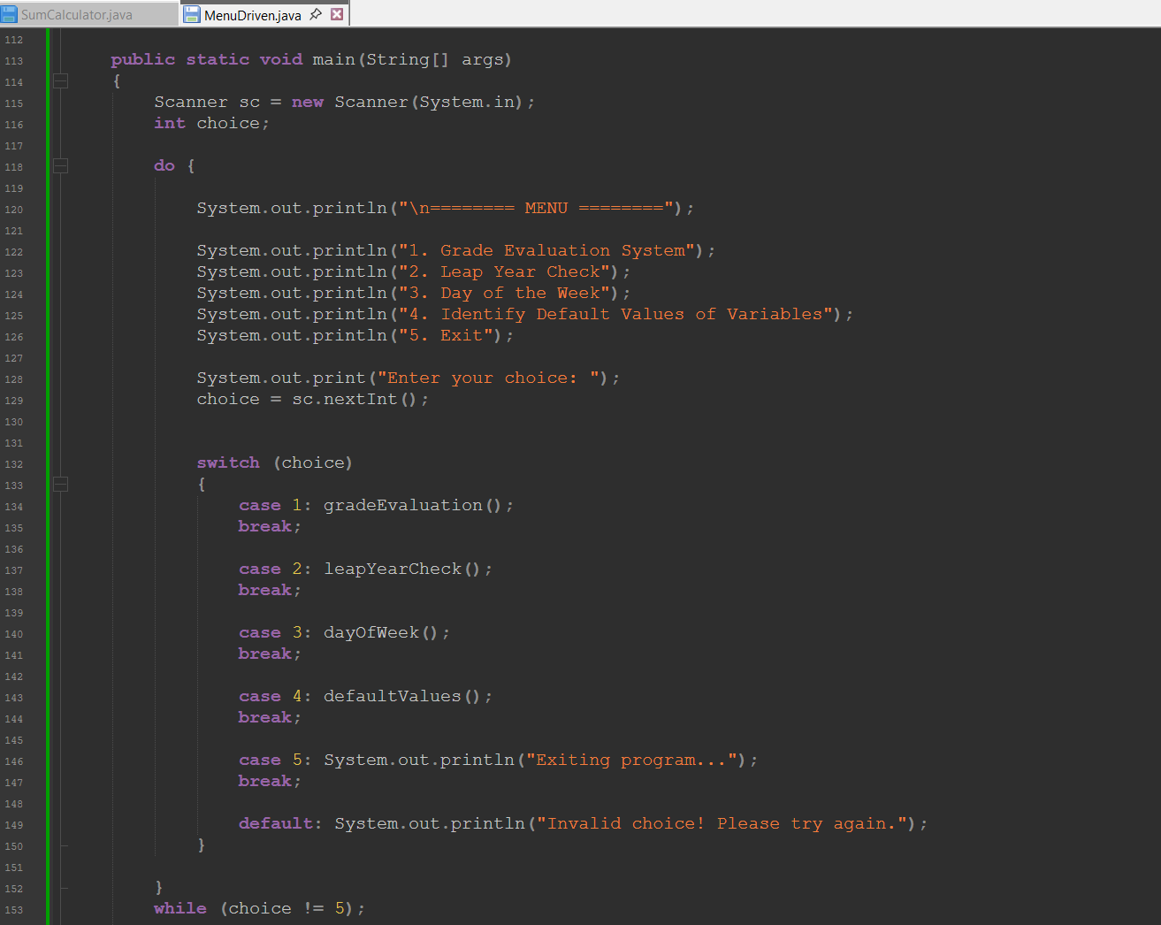

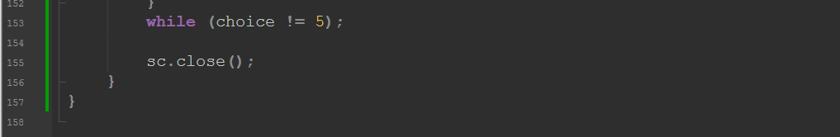

**Output:**

